C4

C3

C2

C1

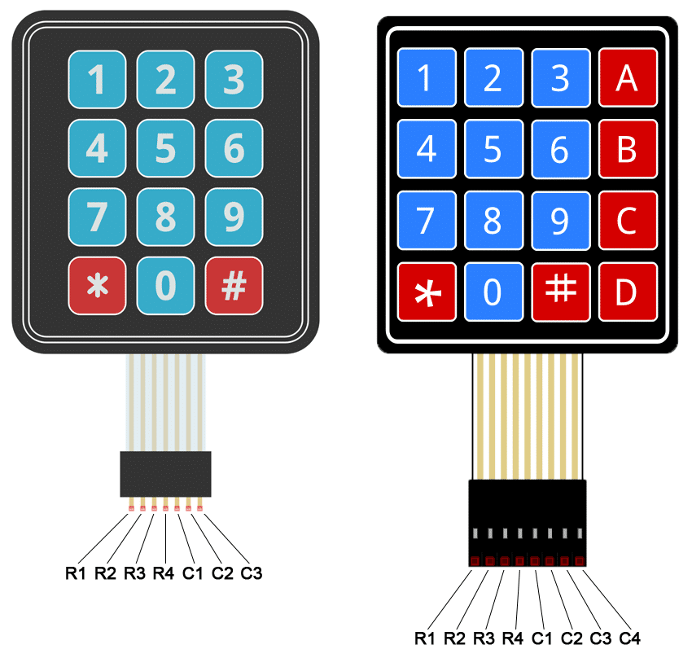

R3

R4

R2

R1

R1 represent the Lowes GPIO of the selected alternative for example, is you choose the the alternative *keypad_PortA.*

R1 => GPIO_A4 C1 => GPIO_A8

R2 => GPIO_A5 C2 => GPIO_A9

R3 => GPIO_A6 C3 => GPIO_A10

R4 => GPIO_A7 C4 => GPIO_A11